Herbivory and competition in endangered mountain yellow-legged frog tadpoles

Thomas C. Smith†, Marina Bozinovic, Yishen Miao, Cherie J. Briggs

Department of Ecology, Evolution, and Marine Biology, University of California, Santa Barbara, California 93106 USA; phone: (805) 893-2888

†email: thomas.smith@lifesci.ucsb.edu

Abstract:

Worldwide declines of amphibian populations and loss of amphibian biodiversity have prompted investigations into the ecological functions of endangered and declining amphibian species. In the Sierra Nevada of California, mountain yellow-legged frogs are nearly extinct, yet we have little explicit knowledge of their ecological interactions, especially for the grazing tadpoles. We performed two experiments to quantify the extent to which tadpole grazing can control abundance of benthic material, and to quantify to the extent to which tadpoles competed with another abundant grazer, mayflies (Ephemeroptera). In field enclosures in two remote high elevation lakes, we manipulated the densities of tadpoles and mayfly nymphs in a response surface design, and measured the abundance of benthic algae biweekly. We found negative effects of tadpoles and mayflies on algal abundance. There was no indication, via length, Gosner stage, or biomass, that tadpoles experienced competition. However, when tadpoles were present at high densities, mayflies were, on average, smaller. To test the effects of consumers on algal abundance independent of potential effects of the lake, we performed mesocosms experiments in which we manipulated the presence and absence of high densities of tadpoles and mayflies. Tadpole presence alone had a negative effect on algal abundance and growth. Taken together, these two results suggest that extinctions of endangered mountain yellow-legged frog tadpoles may allow benthic producers to reach higher abundance and biomass.

1. Introduction

Amphibians are declining in diversity and abundance worldwide (). These declines and extinctions of populations and species will have consequences for the communities in which amphibians live (cite Paine about removing predators, cite Gruner about removing grazers, cite someone about effects of loss of diversity on communities), but the magnitude of these consequences is likely to vary. Most species probably do not have strong interactions with their prey, competitors, or predators (), so not all species declines will have significant community consequences. The breadth of ecological interactions utilized within the class Amphibia is also very broad () because individuals of many amphibian species undergo ontogenetic niche shifts from herbivores to predators, and because ceacilians, salamanders, and frogs and toads occupy subterranean, terrestrial, and aquatic habitats nearly from pole to pole and from sea-level to high mountain lakes (). Therefore, predictions about the extent to which any species’ decline or extinction will affect that taxa’s community should use quantitative descriptions of its interactions and effects on communities and ecosystems (cite something about things required to described intereaction strengths, food web connections, model parameters etc).

* 1. Effects of Amphibian declines
     1. Amphibians declining worldwide
     2. These declines have consequences, and, they may matter.
     3. Predictions about ecological effects of amphibian declines are made
        1. But do we really have enough information about species’ ecology to make these predictions
     4. May depend greatly on the identity and ecology of the species
        1. Not all species have strong interactions
        2. Amphibians are an ecologically diverse group
     5. Requires specific knowledge about species ecology

Tadpoles represent a subset of the breadth of amphibian taxonomic and functional diversity, and their potential to be ecologically important is well supported (Alford 1999 in Tadpoles, Altig et al 2007). As benthic grazers, many tadpoles can dramatically reduce the abundance of benthic producers (hereafter, algae, with no regard to propriety) (Lamberti 1992, Dickman 1968, Morin et al 1990, Holomuzki 1998 as in Alford 1999, and Kupferberg 1997a, 1997b, Connelly et al 2014). Because of this ability to control resources, tadpoles can also act as competitors, both intra- and interspecifically, via both exploitation and interference. There are examples of tadpoles affecting growth or populations of other taxa through competition: newts (Alford 1989), mosq. larvae (Blaustein and Margalit 1994, 1996) snails (Bronmark, 1991), insects (Kupferberg 1997b) or being competitively affected by insects (exploitation Morin et al 1988)

Exploitation:

Interference: seems mostly to occur between tadpoles (intra and interspecific)

* 1. Tadpoles can be important ecologically
     1. Can reach high densities, more abundant than adults, constrained to aquatic habitats
     2. Lots of amphibian ecology work has focused on tadpoles
     3. Some tadpoles are grazers, e.g. Ranidae, one declining taxa (in NA)
     4. Herbivory
     5. Competition
        1. exploitation
        2. interference
     6. other ways: as food, as nutrient cyclers, as sediment movers
  2. Potential effects of tadpole loss
     1. Predatory and competitive release of algae and other grazers
     2. other ways: as food, as nutrient cyclers, as sediment movers

The endangered mountain yellow-legged frogs (*Rana muscosa* and *R. sierrae*) of the Sierra Nevada fill ecological roles which the loss of could alter whole lake communities. For this study, we focused on tadpoles. Mountain yellow-legged frog tadpoles are grazers of benthic algae (almost entirely diatoms) which makes them potential competitors with mayfly nymphs, caddisfly larvae, diptera larvae, and other benthic macroinvertebrates. Tadpoles are also prey to large predatory aquatic insects, adult frogs, and birds, via which they form part of an aquatic-terrestrial food web linkage. Tadpoles also excrete ammonia as a product of metabolism, and thereby contribute to spatial heterogeneity in distribution of dissolved nutrients. This suite of ecological functions may initiate cascades following the extinction mountain yellow legged frogs and tadpoles.

The mountain yellow legged frogs were once extremely abundant, with thousands of tadpoles in many lakes, reaching densities of nearly 60 tadpoles per meter of shoreline in some lakes (Roland A. Knapp, unpublished data) and distributed in streams in the Transverse Ranges of southern California and in lakes and streams along both sides of the entire range of the Sierra Nevada mountains. Dramatic declines in the range and abundance of frogs and tadpoles were been driven initially the introduction of non-native predatory trout, but more recently have been exacerbated by the emergence and spread of the amphibian chytrid fungus, *Batrachochytrium dendrobatidis*. Now, large frog (and tadpole) populations are limited to a handful of populations in extremely high elevation lakes in Yosemite and Sequoia/Kings Canyon National Parks and the adjacent John Muir Wilderness in the southern Sierra. In most lakes in the Sierra Nevada, tadpoles are locally extinct.

* 1. Mountain yellow-legged frog declines and ecology
     1. In the Sierra, tadpoles are grazers, potential competitors, within and cross-habitat food source, nutrient cyclers
     2. Once reached densities of…
     3. And were distributed from…
     4. Have declined due to
        1. Fish – as prey
        2. Disease – as reservoir hosts that suffer mortality at metamorphosis but not replaced b/c adults are gone.
     5. Current distribution of tadpoles in lakes…
        1. with densities of zero…

Our objective was to describe potential effects of mountain yellow-legged frog tadpole declines and extinctions on Sierra Nevada lake communities by quantifying tadpoles’ impacts on their resources and on potential competitors. We predicted that in the presence of tadpoles, algal abundance would be lower, and that higher densities of tadpoles would reduce algal abundance more. In addition, we predicted that mayflies would also reduce algal abundance, and tadpoles and mayflies together would reduce algal abundance additionally. We also predicted that body sizes of each consumer would be reduced by increasing intraspecific and interspecific densities. To investigate these predictions, we performed an *in situ* field enclosure experiment and a mesocosm experiment. The results of these experiments should clarify how the extinction or removal of mountain yellow-legged frog tadpoles from Sierra Nevada lakes will affect algal resources and other aquatic grazers.

* 1. Predictions/hypotheses:
     1. Do these tadpoles matter? What might be the effect of their extinctions?
     2. Objective:
        1. To quantify the effect of MYLF tadpoles on resources and a potential competitor
     3. Overall hypothesis: tadpoles reduce algal abundance and indirectly affect mayflies, through exploitation
     4. In field enclosures: Abundance of algae lower in presence of tadpoles, and more so with higher densities of tadpoles
        1. both consumers exhibit both intra and interspecific competition, with the amount of algae abundance not being reduced “linearly” as consumer abundance increased.
        2. Tadpoles are smaller or slower growing at high densities
        3. Mayflies are smaller or slower growing/less emergent at high densities
        4. Mayflies are smaller or less emergenent in presence and at high densities of tadpoles.
     5. In Mesocosms, presence of tadpoles and mayflies reduces algal abundance/growth
        1. Tadpoles reduce algae
        2. Mayflies reduce algae
        3. Algae reduced more when both present
        4. Tadpoles and mayflies each smaller when together

Methods

We performed two experiments, a field experiment and a mesocosm experiment. Our field experiment allowed us to describe, within the natural setting of two remote high elevation lakes, the interactions between two consumers: tadpoles (*Rana muscosa* and *Rana sierrae*) and mayfly nymphs (Ephemeroptera, *Callibaetis ferrugineus* and *Ameletus spp.*), and their shared resource, benthic organic matter which consists largely of diatoms (hereafter, algae). In the mesocosm experiment, we tested the effects of the same grazer in artificial habitats which controlled for natural nutrient, temperature, substrate heterogeneity found within most lakes.

In the field enclosure experiment, we use a response surface design () to characterize the independent and interactive effects of grazers. Response surface designs facilitate description of intra- and interspecific interactions, as they allow two factors to vary alone and together. For each of our two consumers, we established four treatment levels, including the absence of and three density levels of each, the highest of which was set by the highest densities of these two consumers we have observed in other surveys (Roland A. Knapp, unpublished data, and Smith et al., in review). Tadpole treatment levels were 0, 2, 10, and 20 individuals, while mayfly treatment levels were 0, 25, 125, and 250 individual mayflies. Each treatment was a pairwise cross of two of these treatment levels, and was replicated once in each of two lakes, except the zero-tadpole/zero-mayfly treatment which was replicated twice in each lake (total n = 34).

The two study lakes were remote high elevation lakes in the King’s Canyon National Park backcountry, referred to as LeConte (3221 m elevation, 37°06'58.78" N 118°38'40.16" W) and Spur (48 km to the southeast of LeConte, 3518 m elevation, 36°43'47.49" N 118°23'38.33" W, (Google Earth 2014)). Both lakes lie close to and west of the Sierra Nevada crest. They are small alpine lakes, however, while LeConte is surrounded by small meadows, white bark pine and willow, and bare rock, Spur is in a basin devoid of vegetation. The water in these lakes has low nutrient concentrations and circumneutral pH: nitrate 0 – 10 μmol L-1, total phosphorus 0 – 1 μmol L-1 (Sickman et al. 2003); median pH ≅ 7 (Bradford et al. 1998). We selected these two lakes because both had large, disease free cohorts of mountain yellow-legged frog tadpoles (R.A. Knapp, personal communication), were relatively accessible, and not in areas frequently used by backpackers.

The 17 enclosures in each lake were placed along the shoreline in the littoral zone, where tadpoles and mayflies feed during the day. Enclosures were 0.5 m wide x 0.5 m tall at one end and 0.5 m wide and 1.5 m tall at the opposite end, and were 2 m long (1 m2 on the bottom). Each was oriented perpendicular to the shoreline, so that the tall end sat in deep water, and the short end sat along the shoreline (Fig. 1). An above-water space was left in the top of each enclosure to accommodate emerging mayflies, and one clean rock was placed inside each enclosure to accommodate metamorphosing tadpoles. Enclosures were supported by a light weight steel frame and guy-lines, and were constructed from Nitex (citation?) and organza fabric, with mesh size of approximately 250 μm. This mesh size prevented escape of mayflies and tadpoles, and prevented invasion by other benthic macroinvertebrates, but allowed movement of sediment, phytoplankton, and small zooplankton (mostly Copepoda).

We captured tadpoles and mayflies in each lake. We captured tadpoles throughout both lakes and after weighing and staging them (Gosner 1960), included those between Gosner stage 26 and 41. In LeConte, tadpoles were *Rana sierrae*; in Spur tadpoles were *Rana muscosa* (Vredenburg et al. 2007). We captured mayflies in the littoral zone of the lakes using benthic sweeps of a standard D-net (mesh size 250 μm), and separated mayflies from other invertebrates in a sorting pan using flexible forceps and a turkey baster. While mayflies were not chosen based on instar, when possible those with wingpads were not included. In LeConte, mayflies were virtually all *Ameletus spp.*, but in Spur, *Ameletus spp.* and *Callibaetis ferrugineus* were present in equal proportions. Algal growth was measured from porcelain tiles placed on the bottom of each enclosure (two sets of 12 porcelain tiles, each 2.4 cm x 2.4 cm, 140 cm2 total area per enclosure). We established a no-consumer pseudo-control for each enclosure by placing a set of tiles in a small bag made of the same mesh as enclosures, and setting it in the littoral zone next to each enclosure. This provided a way to account for within lake heterogeneity in algal growth. To account for potential differences in algal communities and light availability within each cage, we recorded substrate type and insolation within each cage. Substrate was described as percent of the substrate below each enclosure which was composed of silt (defined as particles < 0.5mm); the percent of substrate composed of silt has been found to be a predictor of community composition in Sierra Nevada lakes (Smith et al. n.d. in review, Knapp and Matthews 2001). Photosynthetic photon flux (solar radiation) was measured within each enclosure at the water surface using a basic quantum meter (Apogee Instruments, Logan, UT).

Experiments began in the early ice-free season (17 July 2009 in LeConte and 21 July 2009 in Spur), and ran in three blocks. Enclosures were sampled every two to three weeks. We collected algae samples from enclosure tiles and from pseudo-control tiles, for later determination of ash-free dry mass (AFDM). At the conclusion of each block, we counted, weighed, and staged tadpoles. We counted mayfly nymphs, and counted and collected emerged adult mayflies. We maintained the densities of these two consumers, despite development and metamorphosis requiring the removal of individuals from enclosures. When tadpoles were older than stage 38 at one visit, they were removed to prevent metamorphosis prior to the next visit; each removed individual was replaced with a younger tadpole. Similarly, adult mayflies which emerged from the nymph stage were replaced by younger individuals. At the conclusion of the entire experiment, all tadpoles were weighed and staged a final time, and released back into the lakes. We collected and preserved all mayfly nymphs from enclosures, and measured them to the nearest 0.1 mm under 10 x magnification.

In order to calculate a length-mass regression relationship for mayflies, we also collected a separate sample of mayflies from each lake. These mayfly nymphs were dried at 105 C for 24 hours, weighed, combusted at 500 C for 1 hour, and weighed again; ash free dry mass was calculated as the difference between the two weights. In order to calculate a Gosner stage-mass regression for tadpoles, we collected, euthanized and preserved in 10% formalin 37 tadpoles from Marmot Lake (3590 m elevation, 37°15'36.33" N 118°41'01.38" W). Ash free dry mass was calculated as it was for mayflies.

Algae abundance was calculated for each enclosure on each sampling date. In the field, algae was scrubbed from tiles using a soft-bristle toothbrush, and suspended in 60 mL of water. Suspended algae were collected on a glass fiber filter with 1.2 μm pore size, using a hand powered vacuum pump. Filters were stored in a cool dark place (under a boulder) in field until they could be frozen in the lab for later processing. Filters were dried at 105 C for at least 24 hours, weighed, combusted at 500 C for 1 hour, then weighed again. Ash-free dry mass was calculated as the difference between filter weights before and after combustion (Hauer and Lamberti 2007). When less than 60 mL of suspension were filtered, we multiplied the AFDM by the fraction of 60 mL that was filtered.

* 1. Field Enclosures (aka “Field”)
     1. Design: response surface, nestedness, blocking, sampling dates
     2. Setting
     3. Enclosures
     4. Animal collections
     5. Sample collection: Algae for AFDM
     6. “Controls”: no consumer ‘bags’ sampled each week also
     7. Other collections
        1. Tadpole wet weights, gosner stage, “emergence”,
           1. Vs. wild tadpoles
        2. Mayfly emergence, identity
           1. Vs. wild mayflies

We also conducted a mesocosm experiment to further explore the effects of tadpoles and mayflies on algal resources, without the environmental variability that occurs throughout lakes. We used a factorial design, with treatment levels for presence and absence of tadpoles and mayflies, arranged randomly among four blocks (n = 16); there were four replicates of the four treatments no consumers, tadpoles only, mayflies only, and tadpoles and mayflies. Four mesocosms contained zero consumers, four contained16 tadpoles, four contained 250 mayflies, and the remaining four contained 16 tadpoles and 250 mayflies.

Mesocosms were located at the Sierra Nevada Aquatic Research Laboratory near Mammoth Lakes, CA (2165 m elevation, 37°36'50.83" N 118°49'57.56" W). We used sixteen cube shaped (1 m x 1 m x 1 m) concrete tanks lined with Thoroseal concrete sealer, with sloping shelves on the south facing side to allow tadpoles and metamorphs to bask (Fig.1). These tanks were filled with water from adjacent Convict Creek; nitrate and phosphate levels in Convict Creek are similar to those observed in most Sierra Nevada lakes (and presumably our two study lakes) however pH is higher than most Sierra Nevada lakes (pH 7.9 – 8.5) (LELAND et al. 1989, Bradford et al. 1998, Sickman et al. 2003). Creek water was the source for algae, and mesocosms were filled in April 2010 to allow algae communities to develop prior to the introduction of consumers. Each mesocosm contained thirty sets of twelve porcelain tiles (similar to those used in the field enclosures, each tile was 2.4 cm x 2.4 cm, total area of 12 tiles x 30 sets of tiles: 2074 cm2) to provide standard surfaces on which we could measure algal abundance; twenty five were placed on the bottom of each mesocosm, and five were placed on each shelf.

We collected 160 *Rana sierrae* tadpoles (Gosner stages 34-39) from Marmot Lake (3590 m elevation, 37°15'36.33" N 118°41'01.38" W) and transported them in one gallon containers with portable aerators and packed in snow. About 3000 mayflies (*Callibaetis ferrugineus*) were collected from a small pond in Yosemite National Park (2608 m elevation, 37°53'07.18" N 119°23'39.97" W) using a D-net with 250 μm mesh size, sorted them using 250 μm sieves, pipettes, and turkey basters, and transported them similarly to tadpoles.

The experiment began in late July 2010 when we added consumers to the mesocosms. We were not able to maintain the mayfly densities, because mayflies were surprisingly difficult to detect in the mesocosms, and apparently experienced high mortality (48% to 100%). Tadpole density was maintained by adding younger tadpoles to replace individuals which metamorphosed and were removed. We ended the experiment when so many tadpoles metamorphosed that we could no longer maintain tadpole densities in the mesocosms. All remaining tiles were then sampled.

In the mesocosm experiment, we sampled algal abundance three times in August. On each date, we sampled bottom tiles and shelf tiles. Tiles on the bottoms of mesocosms were exposed to grazing for one, two, and three weeks; on the first sample date 15 tiles were removed from mesocosms, sampled for algae and replaced, on the second date, 5 previously sampled tiles were removed, sampled again, and replaced, then on the third date all remaining tiles were removed and sampled. Four out of five tiles on the shelves were sampled each week and replaced; the fifth was sampled only at the end of the experiment. For all tiles, we scrubbed algae from each tile, suspended it in 60 mL of water, and filtered the suspension onto a glass fiber filter, as described above. These samples were frozen immediately, and later processed for AFDM as described above. When less than 60 mL of suspension were filtered, we multiplied the AFDM by the fraction of 60 mL that was filtered. At the conclusion of the experiment, we measured size (body length not including tail length) and developmental stage (Gosner stage) of at least 10 tadpoles from each mesocosm. We sampled each mesocosm for mayflies using the same D-net used to collect them, until 10 back to back sweeps collected no more mayfly nymphs. Mayflies were counted, but not measured.

* 1. Mesocosms (aka “Mesocosm”)
     1. Blocking, randomization, sampling dates
     2. Animal collections/transportation
     3. Mayfly issue
     4. Sample collection: Algae for AFDM
     5. Other collections
        1. Tadpole
  2. Lab Processing
     1. AFDM of algae
     2. Tadpole, mayfly AFDM
  3. Analytical Methods
     1. Summary statistics –
        1. datasets separated by lake?
        2. Temporal patterns – or averaged over times?

*Analytical methods. –* For our analysis of field enclosure data, we used two sets of independent variables in alternative analyses. In one, the two independent variables were the categorical variables mayfly density and tadpole density, with four levels for each density treatment of each consumer. We also included a categorical covariate for lake, with two levels (LeConte and Spur). This covariate accounted for differences between lakes such as elevation, temperature, or size. We also included continuous covariates for days between samples, solar radiation within enclosures, and substrates beneath enclosures.

Alternatively, instead of using the categorical variables for mayfly and tadpole density, we used total ash free dry mass weights estimated for each consumer within each enclosure. For mayflies, per-enclosure AFDM was estimated based on the average mayfly mass calculated from a length-mass regression relationship and the number of mayflies counted in each enclosure. We used the length-mass relationship to calculate the total estimated AFDM for mayflies in each enclosure based on the lengths of the individuals we had measured. For tadpoles, we used the Gosner stage-mass relationship to estimate the total AFDM for tadpoles from each enclosure, based on the Gosner stages we observed for each tadpole. These biomasses for each consumer were used as continuous independent variables in our analyses, with the same covariates described above.

Our response variables of interest was, for each enclosure, algal abundance (algae AFDM m-2). We used linear mixed effects models (Zuur et al. 2009) to test the effect of consumer density and consumer biomass on algal abundance, with response variable algal abundance, predictor variables tadpole and mayfly abundance or biomass, and covariates siltiness, radiation, lake, and experimental block. To meet the assumption of normality of residuals (Zuur et al. 2009), we log transformed raw algal abundance. We compared models that included random intercepts (for block and for lake), random slopes for consumer effects in different lakes, and allowed variance to differ among experimental blocks, lakes, and levels of mayfly and tadpole density (Zuur et al. 2009).

To account for within lake variability in algal abundance, we also corrected raw algal abundance by subtracting from it the algal abundance in pseudo-control tiles and repeated analyses. In this analysis, basic transformations did not increase normality of residuals in a simple linear regression model which included the response variable algal abundance, the predictor variables tadpole and mayfly abundance or biomass, and the covariates siltiness, radiation, lake, and experimental block. Therefore…

In our analyses of mesocosm algal abundance, the independent variables were tadpole abundance and final mayfly abundance. We included covariates for tile location (categorical; shelf vs. bottom) and period of algal growth (days). We used… linear models, normality, homogeneity of variance. We included a random effect (intercept) for mesocosm number nested within experimental block.

* + 1. Independent variables
       1. Factors:
          1. F: Mayfly density, Tadpole density, estimated biomasses, change in estimated consumer biomass
          2. M: Tadpole presence/estimated biomass
       2. Covariates: Days of growth/Days in Block, substrates, insolation,
       3. Random:
          1. Field:

lakes (encompasses temperature, elevation, nutrient availability, etc)

date/Sample Number/block

* + - * 1. Mesocosm: block
    1. Dependent variables:
       1. Any of
          1. Algae AFDM,
          2. Algae AFDM/m2,
          3. Algae Growth Rate: change in AFDM between two samples, and Algae Growth Rate per m2.
          4. “Control Difference”: The experimental AGR/m2 subtracted from the “control” AGR/m2
       2. Field also included:
          1. Tadpole size/weight/stage
          2. Mayfly

1. Results
   1. Field

Results

*Field enclosure experiment. –* Tadpoles and mayflies both had negative effects on the abundance of algae in field enclosures. The best fit linear model (Table 1) of the raw algal abundance used log-transformed raw algal abundance to meet the assumption of normality of model residuals. We also tested models that allowed the slope of the relationship between each consumer and algal abundance to differ between the two lakes, and an additive model with a non-linear relationship between silt and algal abundance; these models were not better. The best-fit model included a random intercept for experimental block, which allowed mean algal abundance to differ among blocks retained lake, tadpole density, and mayfly density as fixed effects (Table 2). The interaction between consumers was not retained as a fixed effect in the best-fit model. In this model, algal abundance differed between lakes, and both tadpoles and mayflies had negative effects on algal abundance (Figure 2, Figure 3).

When we considered controlled algal abundance, both tadpoles and mayflies still had negative effects on algal abundance. The best fit linear mixed effects model of pseudo-controlled algal abundance (Table 3) included random intercepts that allowed the mean controlled algal abundance to differ with respect to experimental block, nested within lake, and allowed variance of controlled algal abundance to differ among experimental blocks and between lakes. The model also included fixed effects for siltiness, and for tadpole and mayfly density (Table 4). The interaction between consumers was not retained in this model. In this model, silt had a negative effect on algal abundance, and tadpole and mayfly density both had negative effects on the controlled abundance of algae (Table 4, Figure 4).

* + 1. Mayfly
       1. Yishen

In the field enclosure experiment, mayflies were smaller at higher densities of both tadpoles and mayflies. Overall, mayflies were larger in LeConte than in Spur, but only Ameletus spp. were available for use in the experiment in LeConte, while in Spur, we used both *Ameletus spp.* and *Callibaetis ferrugineus*. In LeConte, Ameletus were smaller in the presence of tadpoles; to the contrary, in Spur, Ameletus spp. was larger in the presence of tadpoles, while *C. ferrugineus* was smaller in the presence of tadpoles.

* + 1. Tadpoles
       1. Marina

Tadpole stage, length, and AFDM did not differ across tadpole density or mayfly density.

* 1. Mesocosm
     1. Mayfly mortality
     2. Algae abundance/growth

*Mesocosm experiment. –* In the 2010 mesocosm experiment, the presence of each consumer had negative effects on algal abundance, but the interaction between the presence of both consumers had a positive effect. The best-fit model included fixed effects for tadpole and mayfly presence, and for their interaction. This model also included a random intercept for tile location, and allowed variances to differ among consumer treatment levels. In the mesocosms, mayflies experienced high mortality or dramatic emergence.

We also calculated growth rates of algae in the mesocosm experiment. Growth rates of algae were… in the presence of tadpoles (Figure 7). The best-fit linear model of algal growth rate was…

Final counts of mayflies indicated that mesocosms lost 48% – 100% of the 250 mayflies which were placed in each mayfly treatment at the start of the experiment. Neither exuvia nor emerged adults were ever observed. This apparent mortality was independent of coexistence with tadpoles; despite a trend towards lower final mayfly abundance in the presence of tadpoles, the difference was not significant (ANOVA, df = 6, F = 0.338, p = 0.58).

Because these final mayfly densities were so different than the initial densities, we analysed algal abundance in the final sample only using tadpole presence and final mayfly abundance, rather than presence, as independent variables. In this case, tadpole presence still had a negative effect on algal abundance, but mayfly abundance had a weak and marginal positive effect on algal abundance. There was no interaction. This model also included a random intercept allowing mean algal abundance to differ between the basking shelf and the mesocosm bottom, and allowed variance to differ with respect to tadpole presence-absence (Table 6).

1. Discussion

In both *in situ* field enclosure experiments and in mesocosm experiments, we found that the presence and density of mountain yellow-legged frog tadpoles had a negative effect on the abundance of algae, and that tadpoles may have negative effects on the average size of individual mayfly nymphs. In the mesocosms, the growth rate of algae was…. These findings suggest that tadpoles of the endangered mountain yellow-legged frogs may have important ecological functions as grazers and competitors. As grazers that can reduce algal abundance, their declines and extinctions may trigger cascading effects throughout alpine lake algal and invertebrate communities. This supports observations and predictions by many others, which suggest that worldwide loss of amphibian biodiversity will have secondary ecological consequences.

1. Discussion outline:
   1. Overview (see above)
   2. discrepancies within each, differences between two experiments:
      1. within:
         1. Enclosure - variation within lakes, variation between lakes
            1. elevation, basin size, productivity, temperature, substrate
            2. highlights how habitat will determine the effects of amphibian declines we can observe, highlights importance of field experiments and observation when discussing extinctions
         2. Enlcosure: alternating effects of tadpole density/presence on mayfly size per species
         3. Mesocosm: alternating effects of mayfly presence vs count on algal abundance
         4. Mesocosm: apparent interference of tadpoles by mayflies
      2. Between
         1. Lack of interaction in field enclosure vs mesocosm
   3. similar results other studies:
      1. other grazing experiments
      2. field/observational/exclusion experiments?
         1. Whiles, or Ranvestal?
         2. Barnum et al 2013: functional redundancy did not exist in trop. Streams, and grazers did not fill isotopic niche vacated by declining amphibians
   4. different results:
      1. other grazing experiments?
         1. Whiles, or Ranvestal?
      2. Smith et al (in review) found little effect of tadpole (and frog) declines
   5. Tadpoles as grazers – and species differences
      1. They’re not all grazers
      2. Declines may be affecting Ranidae more than some taxa, in which tadpoles are mostly benthic grazers
      3. But even so, differences between species and differences between habitats will determine effects of extinctions
         1. Broad statements about effects of amphibian declines may not be useful.
         2. Because ecology depends on species and habitats
   6. Predictions based on our results
      * 1. additional research needed
      1. We did not quantify overall algal abundance in lakes
         1. Climate: Will lake temps be higher and encourage higher growth, uncontrolled by grazers? Will increased non-winter ppt increase nutrient inputs into lakes? Will increased t-storms and convection tip lake limitation from N to P (or vise versa) and enhance algal growth?
      2. declines in water quality? Links between algal abundance and desirable water chemistry?
      3. Positive responses by undesirable taxa (e.g. grazing mosquito larvae?)
         1. Did not appear so based on Smith et al in review
   7. Other effects of MYLFs in Sierra
      1. Predation by adults
         1. would complement loss of tadpole grazing as a releases of pressure on MF populations
         2. But little effect on communities; little effect observed for MFs in frog-extinct lakes
      2. Nutrient effects of tadpoles
         1. Tadpoles can cycle nitrogen, ammonia
            1. Field observations
            2. The ammonia and nitrate values were higher in tadpole mesocosms.
         2. This experiment suggests that if there is a positive effect of ammonia on algal abundance, it is less than the overall negative effect of grazing
         3. We have seen, and are investigating, positive influence of tadpole cycled ammonia on algal diversity with respect to grazing
   8. Conclusions

References

Tables

|  |  |  |  |  |
| --- | --- | --- | --- | --- |
| Fixed effects | Response variable transformation | Random effects | Heterogeneity of variances | AIC |
| Tadpole Density x Mayfly Density + Lake +  Days in Block + Silt + Radiation + Block |  |  |  | 452.07 |
| Tadpole Density x Mayfly Density + Lake +  Days in Block + Silt + Radiation + Block | Log transformed |  |  | 327.75 |
| Tadpole Density x Mayfly Density + Lake +  Days in Block + Silt + Radiation | Log transformed | Block |  | 329.5  But residuals more normally distributed |
| Tadpole Density x Mayfly Density +  Days in Block + Silt + Radiation + Block | Log transformed | Lake |  | 334.0 |
| Tadpole Density x Mayfly Density +  Days in Block + Silt + Radiation | Log transformed | Block nested in Lake |  | 335.05 |
| Tadpole Density x Mayfly Density + Lake +  Days in Block + Silt + Radiation | Log transformed | Block | By lake | 300.4  Increases non-normality of residuals |
| Tadpole Density x Mayfly Density + Lake +  Days in Block + Silt + Radiation | Log transformed | Block | By block | 327.5  Increases non-normality of residuals |
| Tadpole Density + Mayfly Density + Lake +  Silt + Radiation | Log transformed | Block |  | 326.8 |
| Tadpole Density + Mayfly Density + Lake | Log transformed | Block |  | 324.9 |

Table 1. Summary of candidate models of raw algal abundance in 2009 field enclosure experiment, using numerical tadpole and mayfly density as the independent variables.

|  |  |  |  |  |  |
| --- | --- | --- | --- | --- | --- |
| Predictor Variable | Linear model coefficient | df | t-value | p-value | Random intercept |
| Tadpole Density | -0.03 ± 0.01 | 96 | -1.8 | 0.0824 |  |
| Mayfly Density | -0.002 ± 0.001 | 96 | -1.3 | 0.19 |  |
| Lake | Mean of algal abundance in Spur 1.1 > than LeConte | 96 | 4.6 | <0.0001 |  |
| Block |  |  |  |  | Variance for the random intercepts: 0.02; variance for the residuals : 1.3; correlation between observation within block 0.02 |
|  |  |  |  |  |  |

Table 2. Terms of best-fit model of log transformed raw algal abundance in 2009 field enclosure experiment, using numerical tadpole and mayfly density as independent variables.

|  |  |  |  |
| --- | --- | --- | --- |
| Fixed effects | Random effects | Heterogeneity of variances | AIC |
| Tadpole Density x Mayfly Density + Siltiness + Radiation |  |  | 362.0 |
| Tadpole Density x Mayfly Density + Siltiness + Radiation | Lake, Block |  | 367.1; but reduces correlation between fitted values and residuals, and enhances normality of residuals |
| Tadpole Density x Mayfly Density + Siltiness + Radiation | Lake, Block | Lake, Block | 231.0 |
| Tadpole Density + Mayfly Density + Siltiness | Lake, Block | Lake, Block | 228.9 |

Table **3**. Models of controlled algal abundance for 2009 field enclosure experiment, using numerical tadpole and mayfly density as the independent variables.

|  |  |  |  |  |  |  |
| --- | --- | --- | --- | --- | --- | --- |
| Predictor Variable | Linear model coefficient | df | t-value | p-value | Random intercept | Combined Variance functions |
| Tadpole Density | -0.0069 | 92 | -1.8 | 0.08 |  |  |
| Mayfly Density | -0.0011 | 92 | -3.7 | 0.0004 |  |  |
| Silt in cage substrate | -0.0015 | 92 | -1.7 | 0.10 |  |  |
| Block (nested in lake) |  |  |  |  | Variance for the random intercept: 0.04; variance for the residuals: 0.10; correlation among observations from same block: 0.15, p=??? | Standard deviation of block 2 and 3 were 64% and 52% of block 1 |
| Lake |  |  |  |  | Variance for the random intercept: << 0.0001 | Standard deviation within Spur was 10x that of LeConte |

Table 4. Description of best-fit model of controlled algal abundance using tadpole and mayfly density (individuals m-2)

|  |  |  |  |  |  |  |
| --- | --- | --- | --- | --- | --- | --- |
|  | Linear model coefficient | df | F | p-value | Random intercept | Combined Variance functions |
| Tadpole | -0.015 | 1, 860 | 84.78 | < 0.0001 |  | Standard deviation 1.04 times larger where tadpoles present |
| Mayfly | -0.000042 | 1, 860 | 10.49 | 0.0012 |  | Standard deviation 1.27 times larger where mayflies present |
| Tadpole x Mayfly | 0.000041 | 1, 860 | 17.27 | < 0.0001 |  | Standard deviation 0.81 times smaller where both consumers present. |
| Tile location (bottom vs. shelf) |  |  |  |  | Standard deviation: 0.092, residual: 0.26 |  |

Table 5. For 2010 mesocosm experiment, ANOVA table for best fit linear mixed-effects model of log10 transformed algal abundance as a function of mayfly and tadpole presence-absence, and on tile on the bottom of the mesocosm or on the tadpole basking shelf

|  |  |  |  |  |  |  |
| --- | --- | --- | --- | --- | --- | --- |
|  | Linear model coefficient | df | F | p-value | Random intercept | Combined Variance functions |
| TadpoleDensity | -0.012 | 1, 496 | 47.392 | < 0.0001 |  | Standard deviation 1.26 times higher where tadpoles present |
| Final Mayfly Abundance | 0.00026 | 1, 496 | 0.563 | 0.46 |  |  |
| Tile location  Difference between bottom and shelf | 0.090 (Shelf tiles lower than bottom tiles) | 1, 496 | 6.90 | 0.0089 |  | Standard deviation 0.77 times lower on shelf tiles than bottom tiles |

Table 6. For 2010 mesocosm experiment, ANOVA table for best fit linear mixed-effects model of log10 transformed algal abundance for samples taken in the final sampling event, as a function of final mayfly abundance in mesocosms and of tadpole presence-absence, and on tiles on the bottom of the mesocosm or on the tadpole basking shelf. The best-fit model included the final mayfly count though is was not a significant fixed effect, and allowed variances to differ among tadpole treatment levels and tile location.

Figures

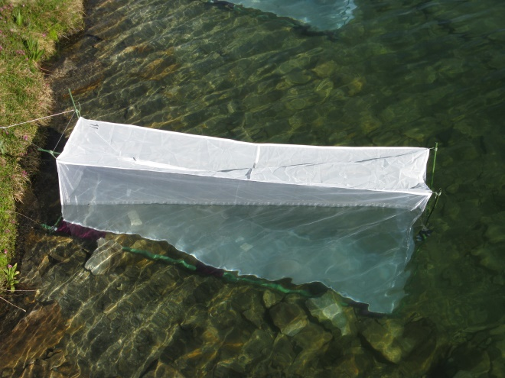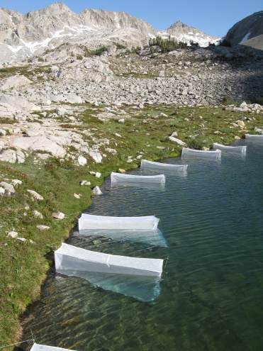

**A.**

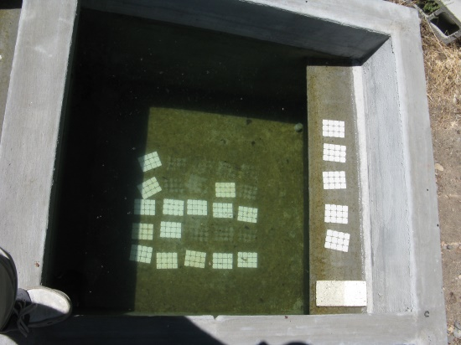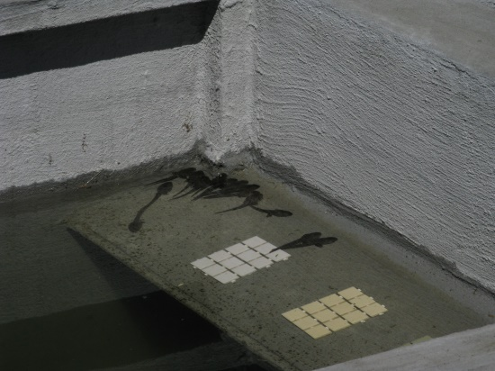

**B.**

FIG. 1. A) Field enclosures in LeConte lake in Kings Canyon National Park, and b) mesocosms located at Sierra Nevada Aquatic Research Laboratory in Mammoth Lakes, CA.

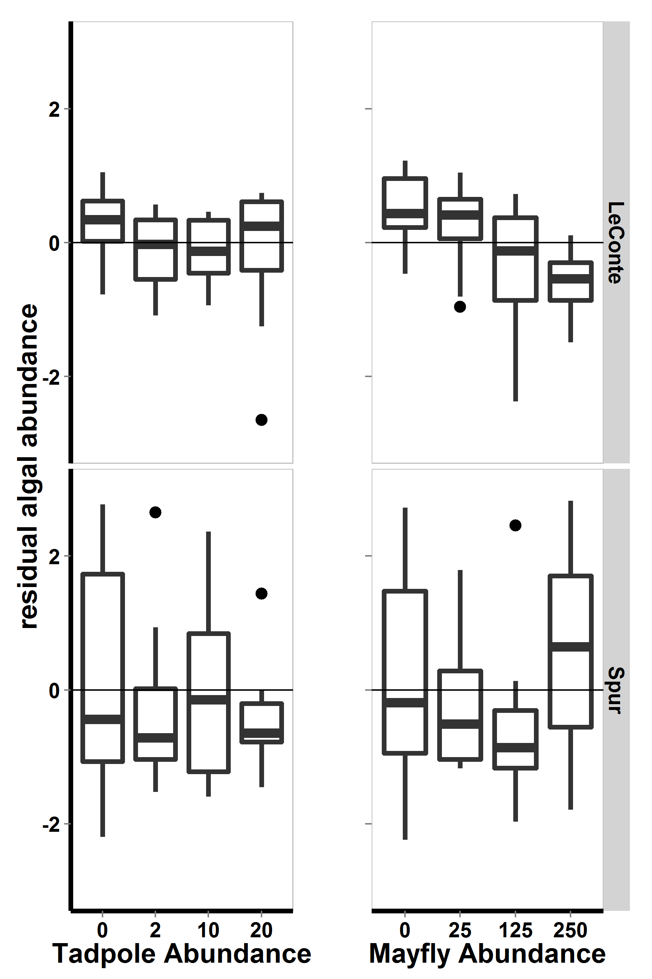

Figure 2. For 2009 field enclosure experiment, a) residuals of model including both consumers with respect to lake, b) residuals of model including lake and tadpole density with respect to mayfly density, and c) residuals of model including lake and mayfly density with respect to tadpole density. Bars show medians, boxes include 50% of the data, and whiskers include 95% of the data.

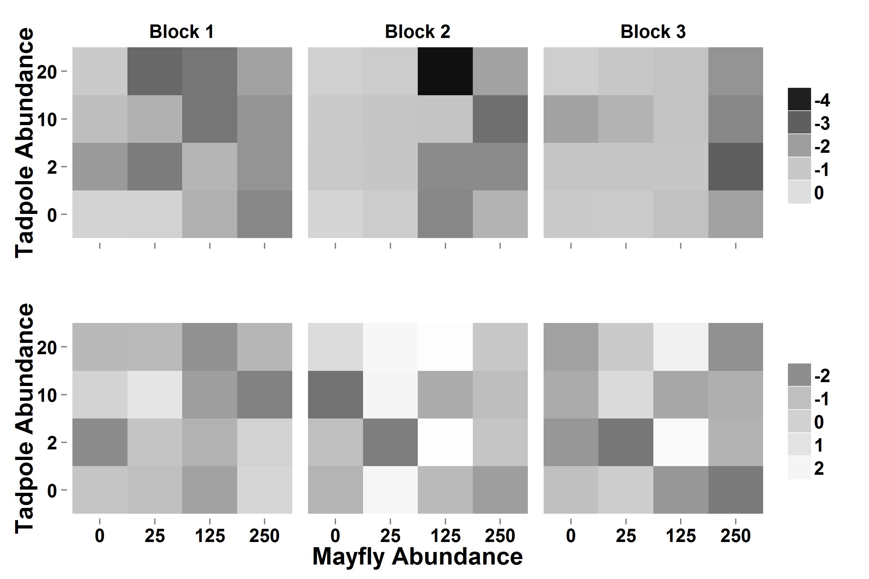

Figure 3. For 2009 field enclosure experiment, heat map displaying log-transformed algal abundance with respect to consumer densities, lake (top: LeConte, bottom: Spur), and experimental block. Darker colors indicate that algal abundance was low, while light colors indicate that algal abundance was high.

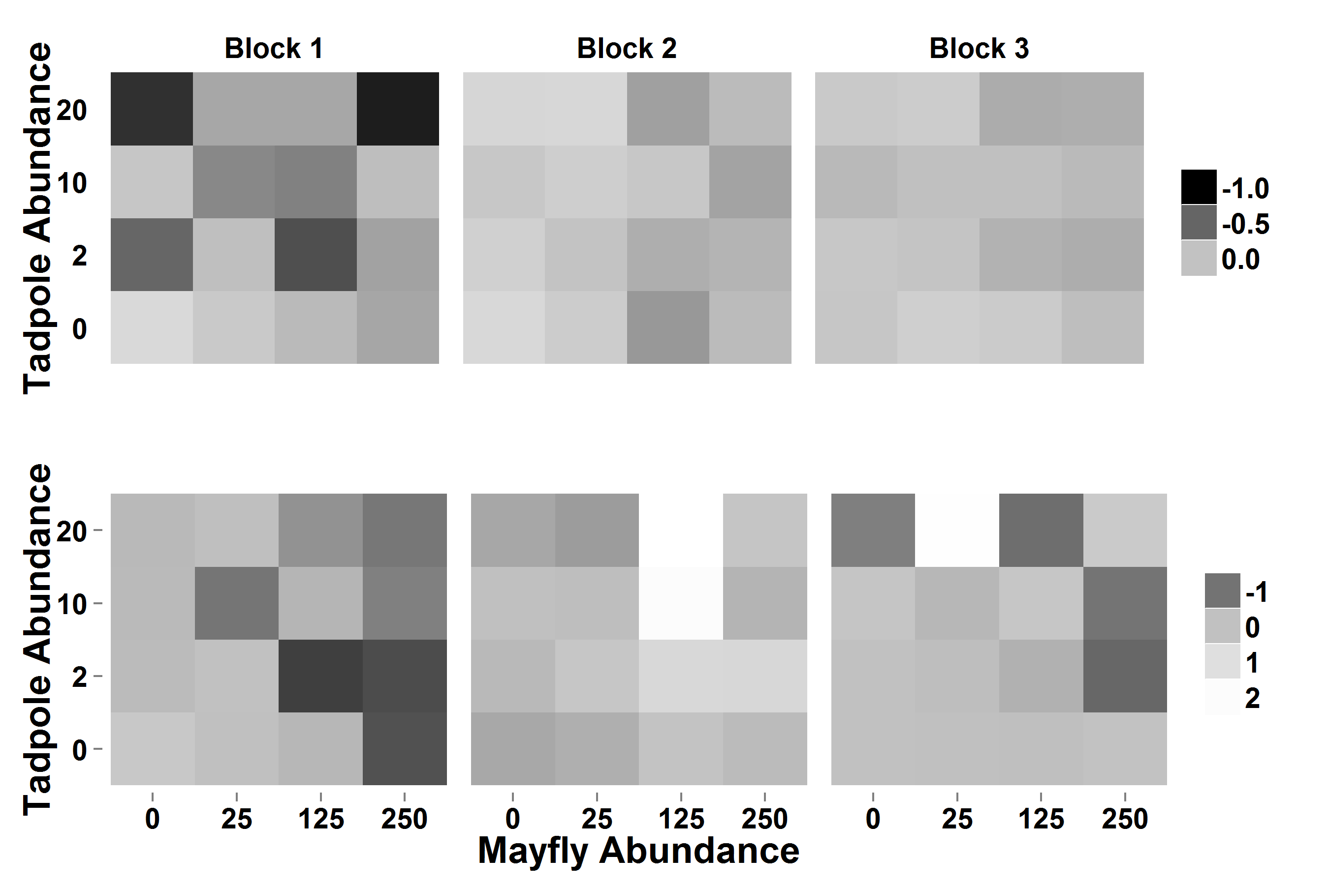

Figure 4. Heat maps showing algal abundance relative to pseudocontrols in experimental enclosure in LeConte (top) and Spur (bottom). For display purposes, the difference between algal abundance in pseudocontol and treatments was log-modulus transformed. Darker colors indicate that algal abundance was lower in the enclosure than in the control, medium gray indicates approximately no difference between controls and enclosures, while light colors indicate that algal abundance was high in enclosures relative to controls.



Figure. For field enclosures, estimated tadpole AFDM (mg, based on Gosner stage-AFDM regression) with respect to tadpole density in enclosures in LeConte (left panel) and in Spur (right panel).



Figure. For 2009 field enclosures, mayfly lengths (mm) with respect to tadpole density (for zero and twenty tadpoles only), to mayfly species, and to lake.

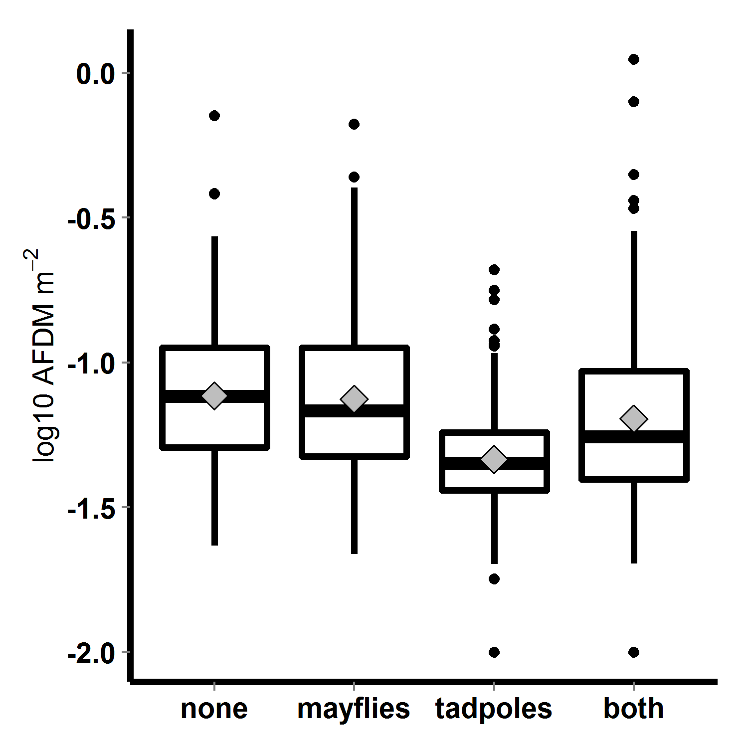

Figure 5. Algal abundance (log10 transformed AFDM) in 2010 mesocosms, with respect to tadpole and mayfly treatments; bars indicate medians, boxes contain 50% of data, whiskers contain 95% of the data, points are outliers, and diamonds indicate means.

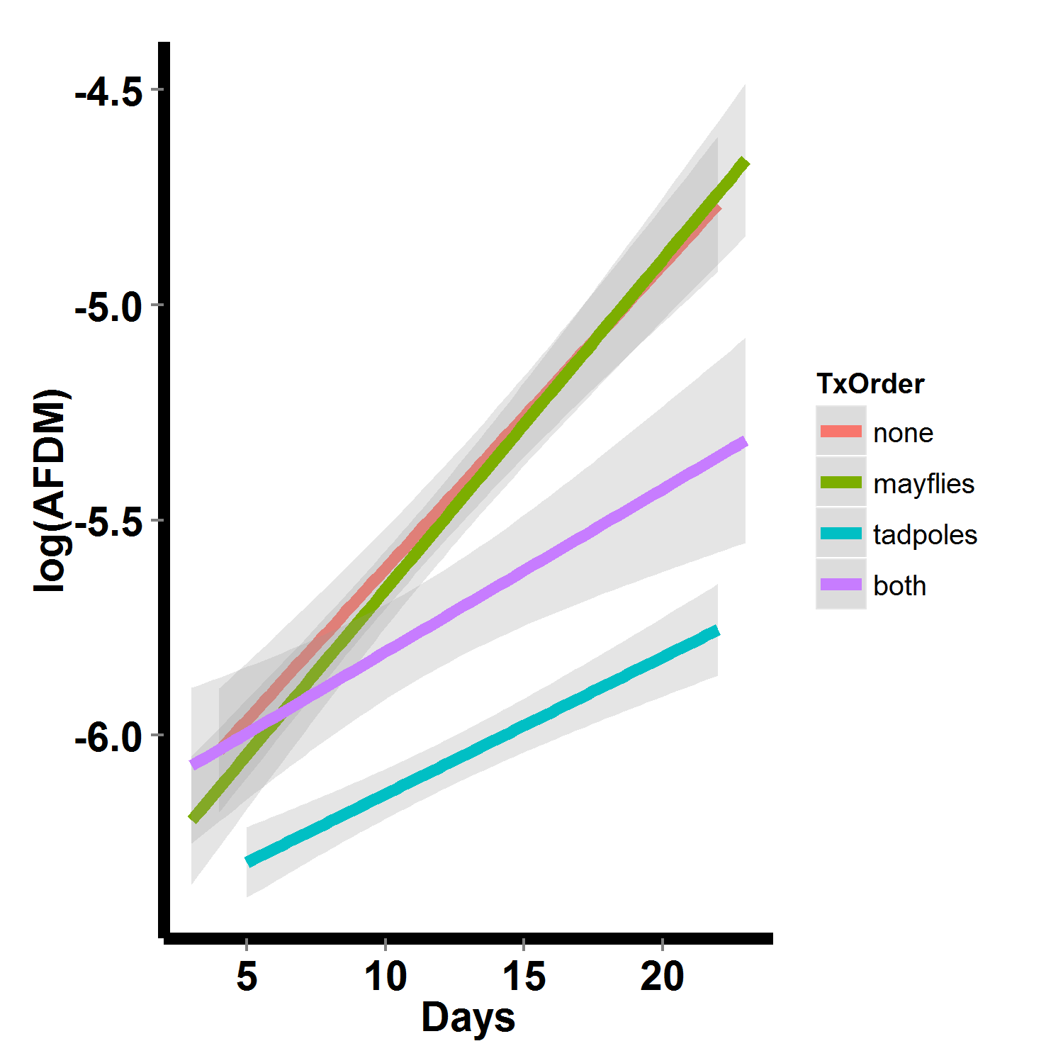

Figure 6. Algal abundance over time in 2010 mesocosms, with respect to consumer treatment. Lines are linear fits with standard error regions around them.